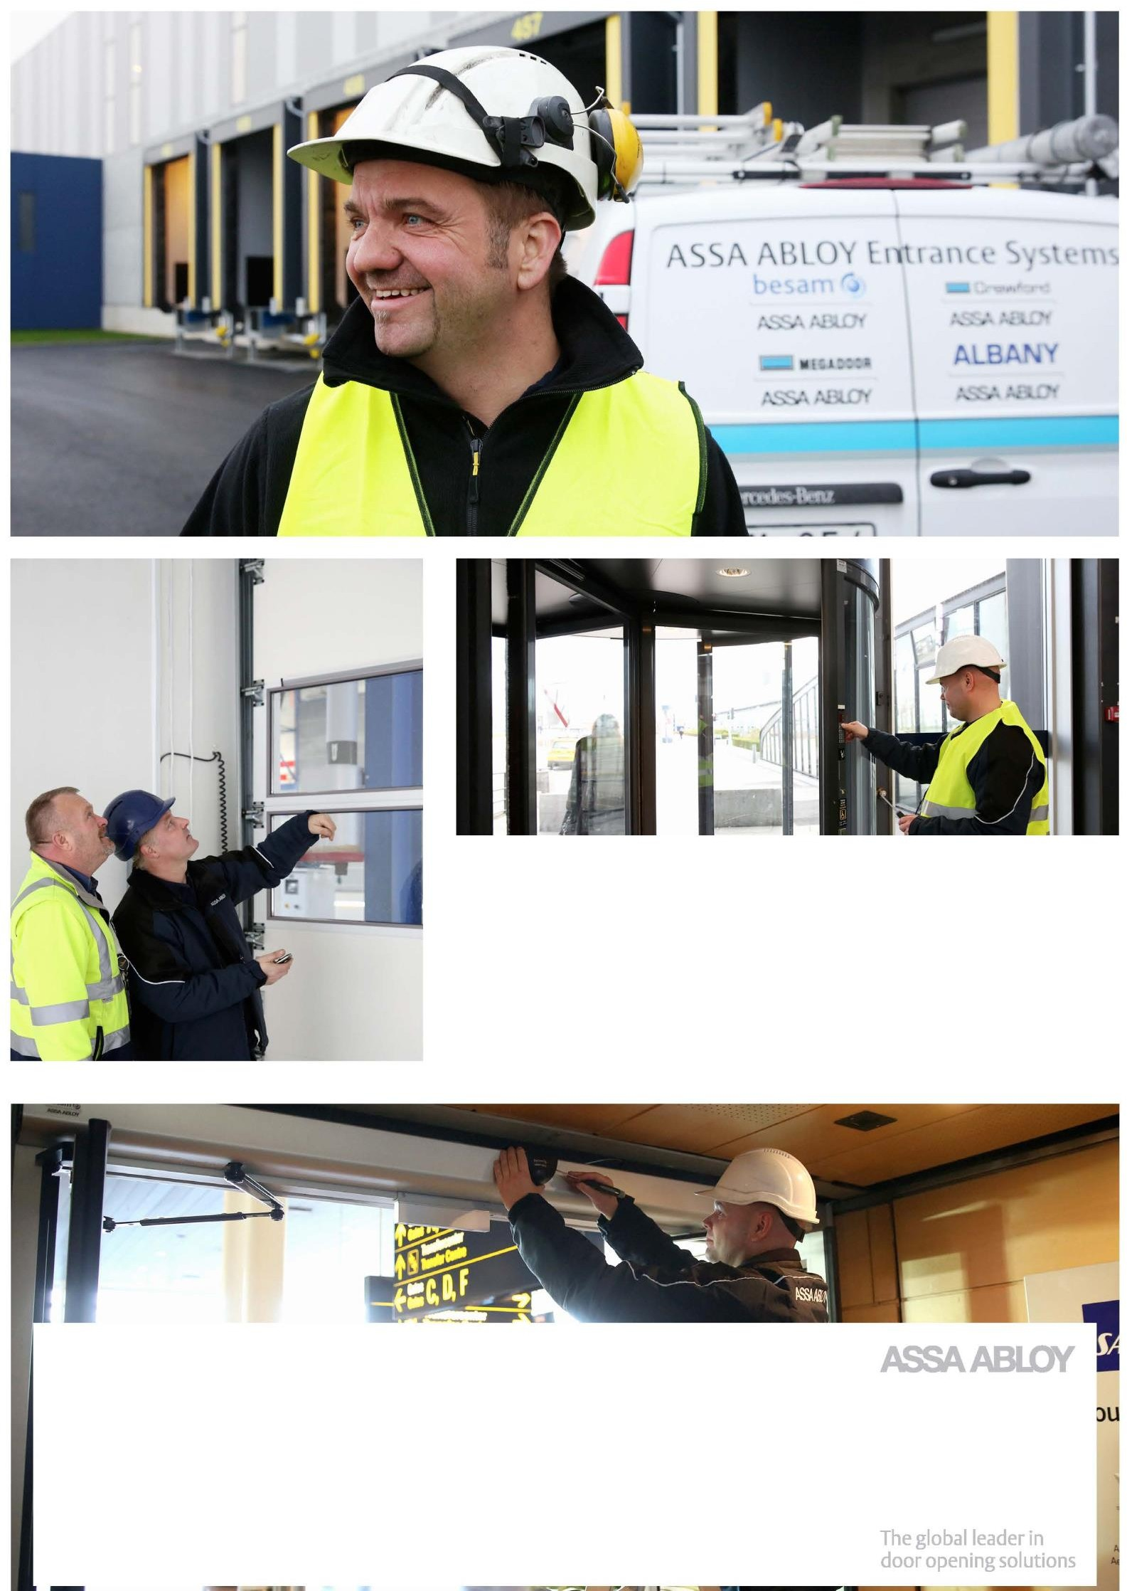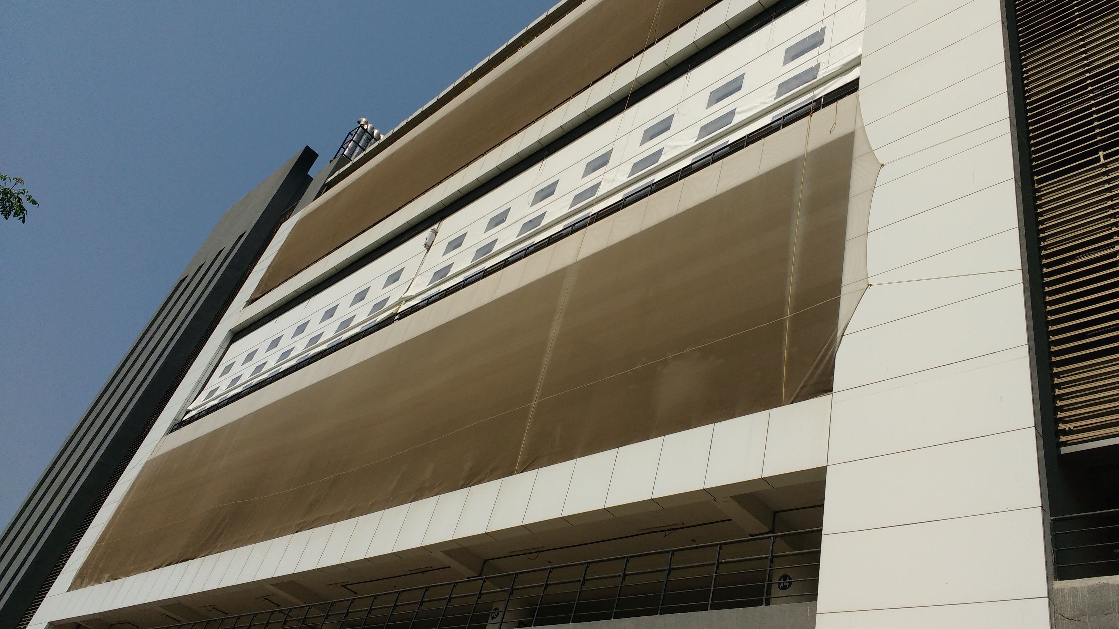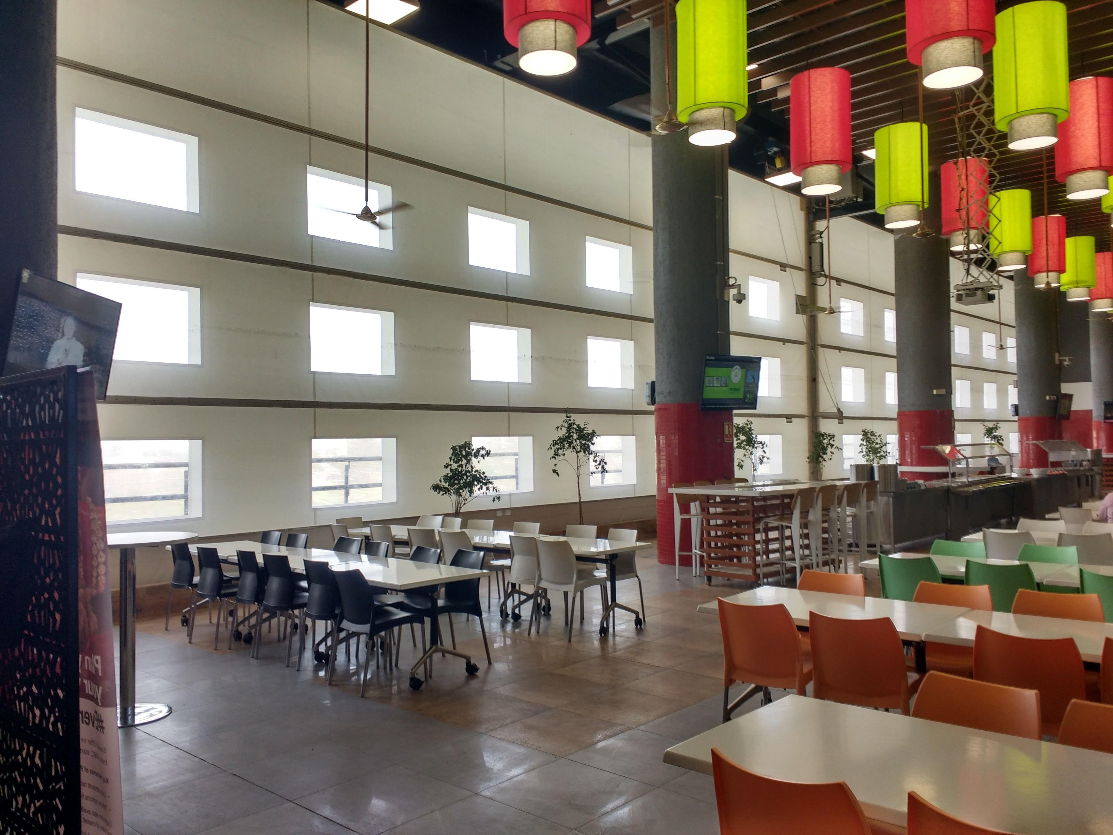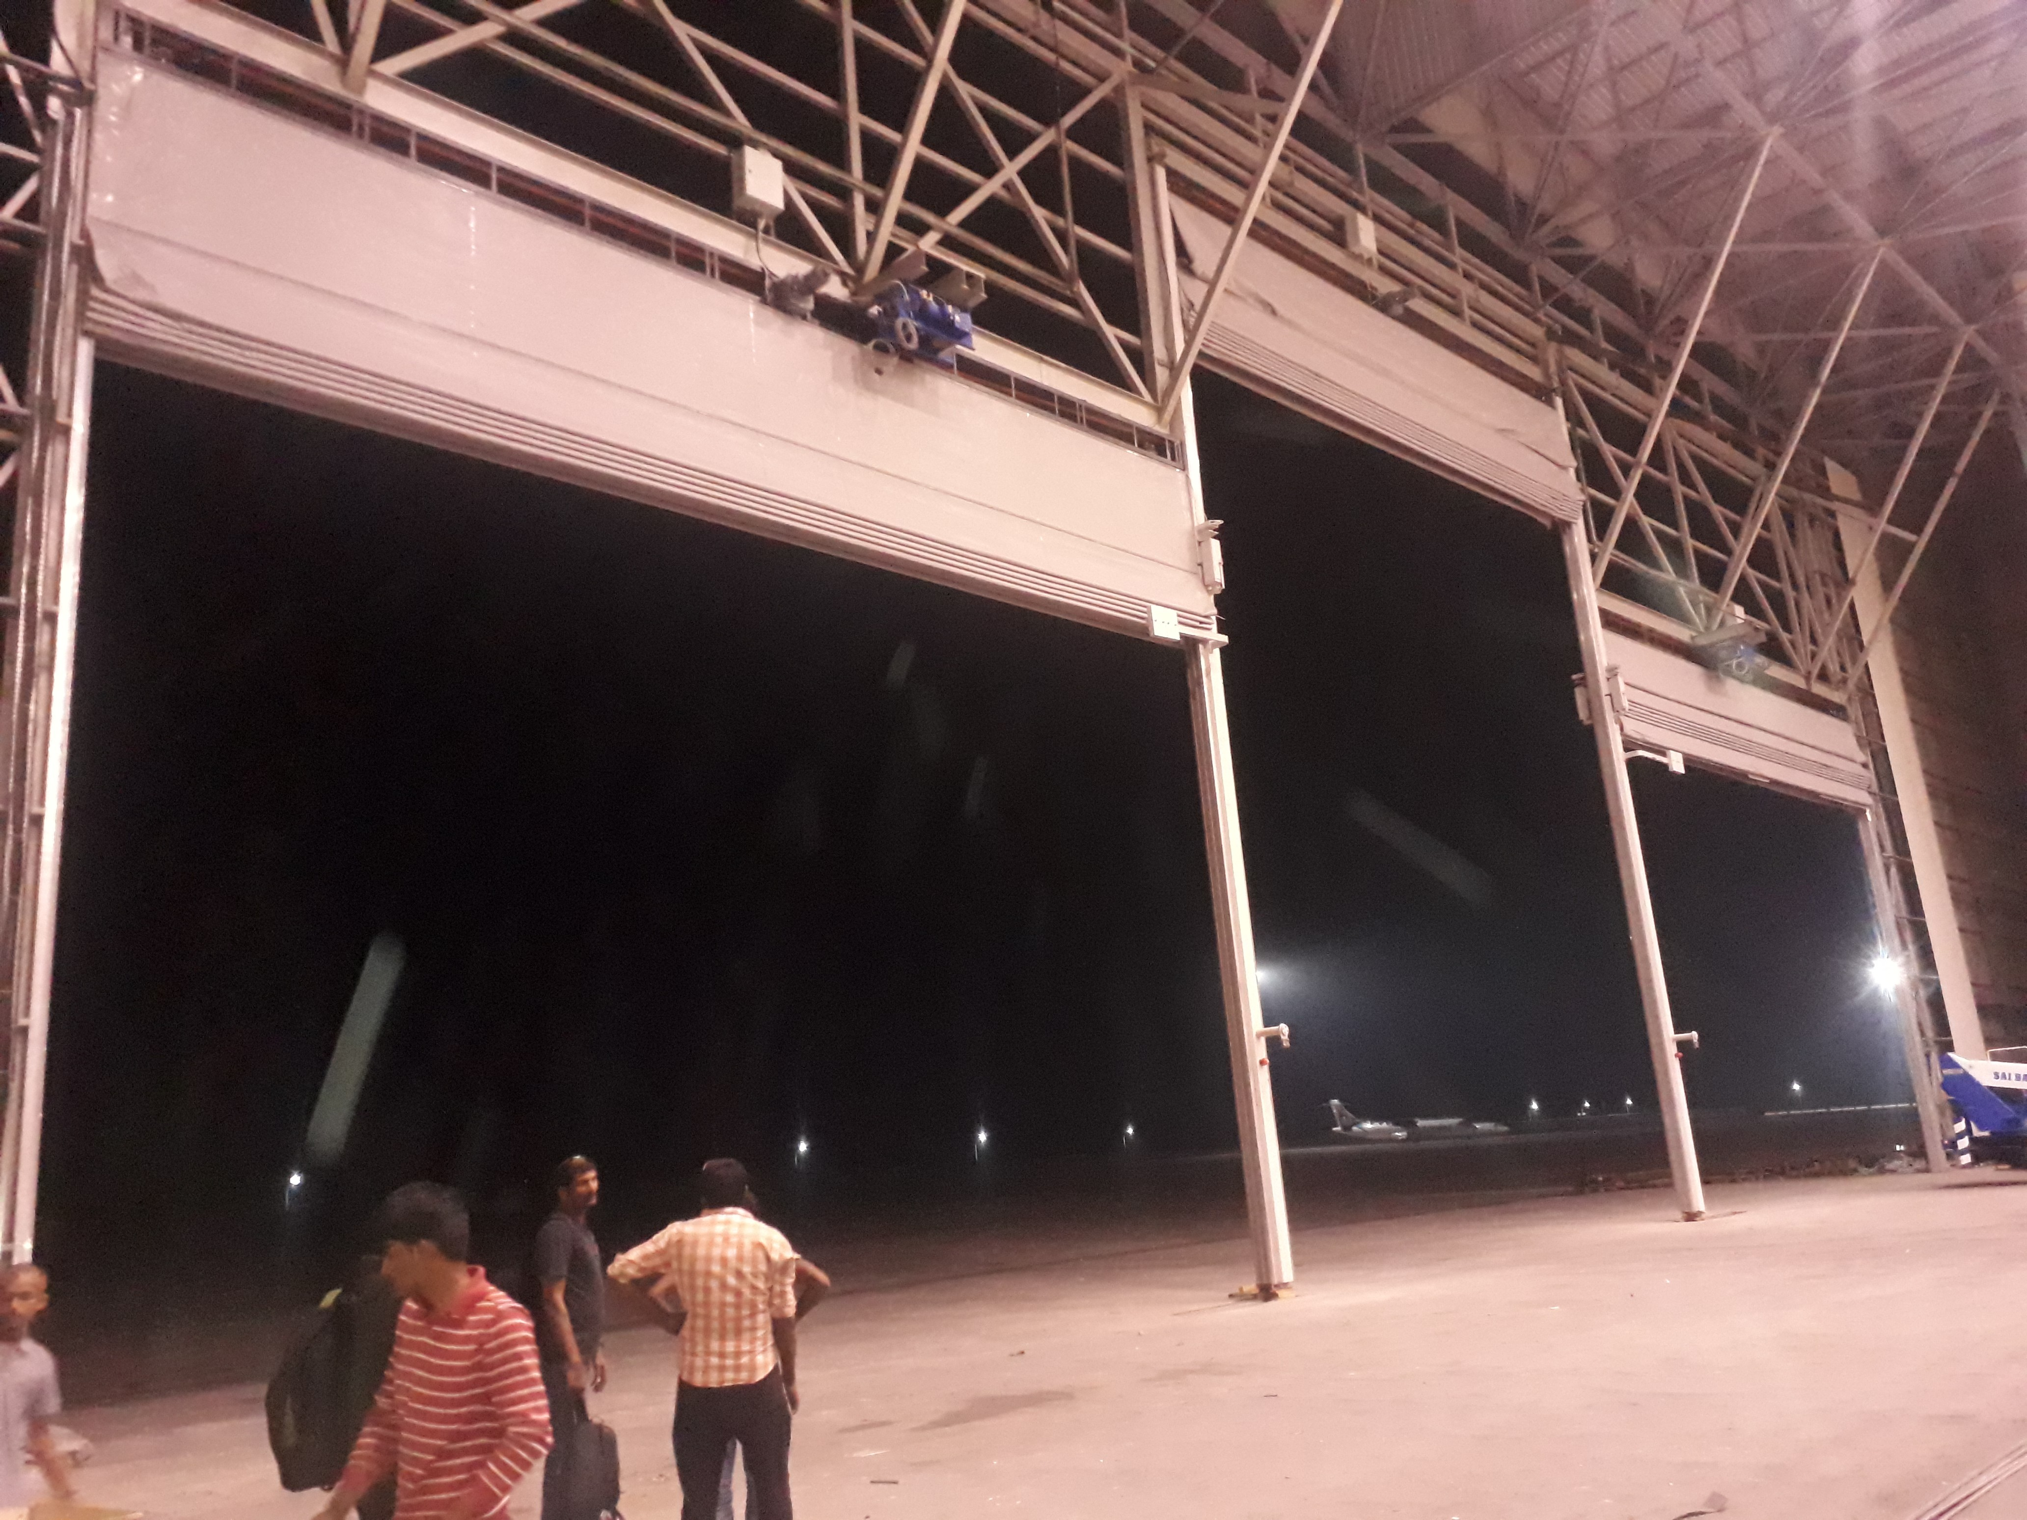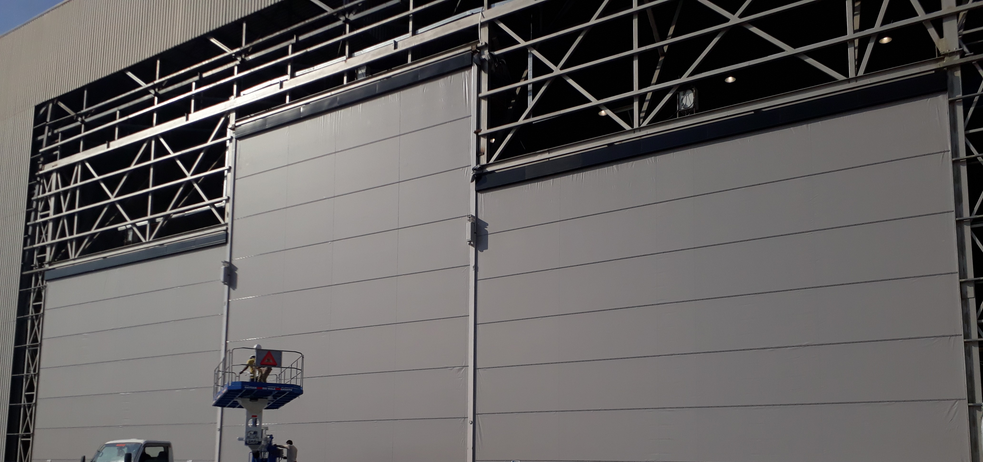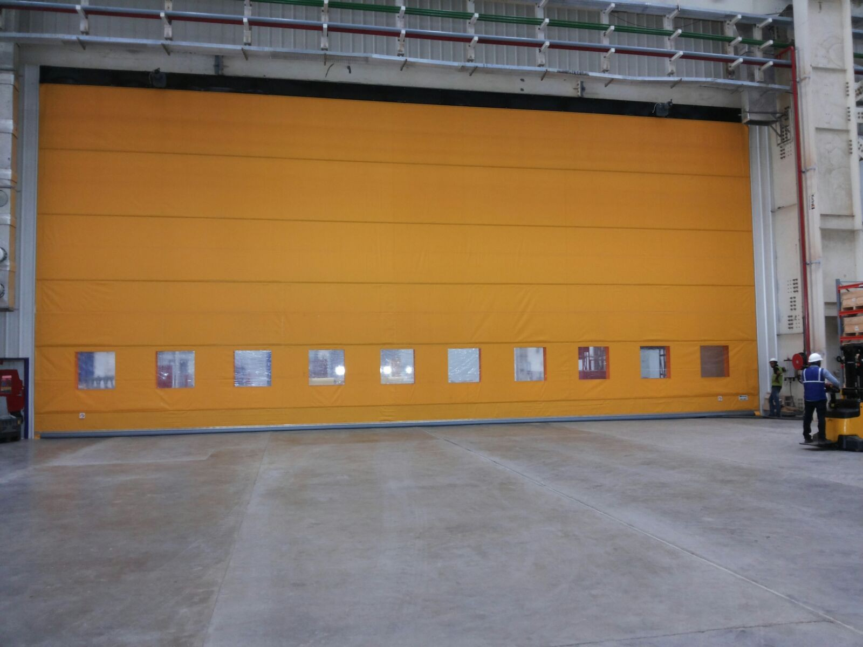

Hangar Door @ GMR Aero Technic Ltd , Hyderabad

To Date : 06.11.2019
GMR Aero Technic Ltd Quotation No: SQT/18-19/ 2216
Mr. Anjaneyulu Gottipati

Project: Annual Maintenance Contract Quotation for GMR Aero Technic Ltd Hangar Door, Hyderabad.

Dear Sir,

We thank you and based on our successive discussions we are pleased to submit our proposal for Annual Maintenance Contract Quotation.

Preventive maintenance is a way to ensure you trouble free operations.

Your benefits:
- Prevents unexpected and expensive break-downs
- Prolongs lifetime
- Cost saving
- Minimizes risk of personal injury
- Minimizes energy loss
- Fulfills legal requirements

Additional benefits: You will get priority in case of breakdowns.

For more information do not hesitate to contact our customer Service department

Yours faithfully
Samruddhi Wakchaure
Service Department
Mob: 9637991333

Key Personnel - Service Dept.
Sr no. | Name | Designation | Contact  number | E mail address
1 | Mr. Sagar Parkale | Project Head | 8551095333 | project@nihva.com
2 | Mr. Amit Kurhade | Asst. General Manager | 7410172333 | amit.kurhade@nihva.com

Annual Maintenance Contract

This agreement is between M/s. NIHVA Technologies Pvt Ltd, 187 G-Block, Thermax Chowk, Chinchwad MIDC, Pune and GMR Aero Technic Ltd, Hyderabad. This agreement is for ASSA ABLOY MEGADOOR installed at M/s GMR Aero Technic Ltd, Hyderabad and the agreement includes:

MEGA DOOR

- Scope of Work

  - Check condition of side guides and slide blocks.
  - Check condition of door fabric, intermediate beams and bottom seal.
  - Check condition of lifting belts.
  - Check operation of limit switches, clean and lubricate as required.
  - Check condition of motors including dust build up in the fans and oil levels.
  - Test the operation of the door using standard push buttons and any additional remote devices.
  - Check and test the safety arrestors.
  - Check and test any safety devices that are fitted.
  - Check the mullion joint.
  - Check the chain hoist.
  - Check list will be submitted after every service.

Visits

- NIHVA Technologies Pvt Ltd will carry out Three (3) services in a year to carry out scope of works as above at for ASSA ABLOY-MEGADOOR of Size: (W)40 x (H)9/14 Mtr door.
- NIHVA will attend two breakdown calls with free of cost.

- The price shall not include the supply of spare parts and consumables.

- Upon discovery of any parts to be replaced, GMR will be advised in writing, the cost for such work to be carried out

Total Mega doors= 1 no. [Size: (W)40 x (H)9/14 Mtr]

Validation of Quotation
The terms and conditions of this quotation are valid for the period of One (1) year.

SN | Product | Year Considered | Rate/door/3visit/year (1 Visit = 5 days)  (INR) | Qty of Door | Total Amount  (INR)
1 | ASSA ABLOY-  Mega door  (W)40 x (H)9/14 Mtr | 01.01.2020 –  31.12.2020 | 9,32,010 | 1 | 9,32,010

Quality & Safety:

“NIHVA” has always been strongly supported by world leaders in automation. Our commitment is to execute projects with highest quality, on time & within the budget while adhering to safety, health and environmental standards and to get established as an icon in providing best engineering, solutions, services and products.
NIHVA values its customers and their businesses and therefore has also built capabilities to provide after sales services. NIHVA is equipped with sophisticated tools and trained engineers to provide quick and efficient service to ensure minimum downtime, prevent unexpected breakdowns and safe work environment.

Prerequisites for Service - Client Scope

- The above terms do not apply in case of abuse, misuse, misapplication or any defects arriving due to negligence or accident. An extra cost will be applicable for Extra Man Power for extra. day (if required) + Spares & payable by you will be quoted separately.

- The above terms do not apply to such products which shall have been installed, altered, or Repaired by any non-authorized person

- Any spare part/ component (if) required, will be at extra costs are not inclusive in the maintenance contract.

- Required Forklift / Scaffolding and necessary help to our service Engineers from client during maintenance of each door in addition to any other charges or fees specified in this Agreement.

- Additional Costs and Charges: The cost of materials and repair if any or extra services shall be charged extra to Customer.

- In addition, on-site maintenance calls (a) in which the Equipment was not the cause of the reported trouble (b) where no trouble was found or © where the call was due to Customer or its representatives improperly following operating instructions for the Equipment, will be billed separately.

- If due to any reason our person need to wait beyond working duration, then Rs. 5,500/- per day working charges will be charged extra.

Other Terms & conditions:
- GST: Extra 18%
- Validity: Validity of offer is 15 days from the date of quotation.
- Payment Terms: 100% advance immediately after the submission of Tax invoice

GST Pune: 27AAECN0437H1ZM
SAC Code: 998732

Please feel free to Contact Mr. Vijay Tarak on 08551093333 For any further Clarification /Information in this Concern.

Regards,
Samrudhhi
NIHVA Technologies Pvt Ltd.

